# Spring Web

## Step 1. Create a Spring Boot project

You can create a Spring project from either IntelliJ or Spring Initializr

* IntelliJ 🡨 Click me to jump to the topic
* Spring Initializr 🡨 Click me to jump to the topic

Note: If you are not able to jump to the topic, use (CTRL + RIGHT CLICK)

### Step 1.1 Start with IntelliJ

* Make sure your directory is empty
* Check Java SDK and Java version
* Java 11 is a Long Term Support Version, which has better maintainance

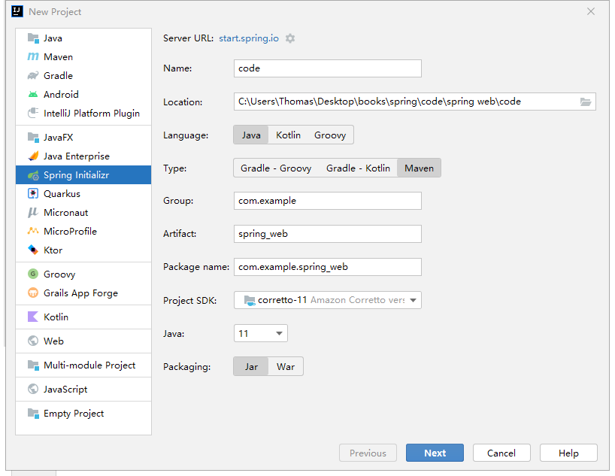

* Include Spring Web to the project
* Select appropriate Spring Boot version according to your java version (version 2.7)

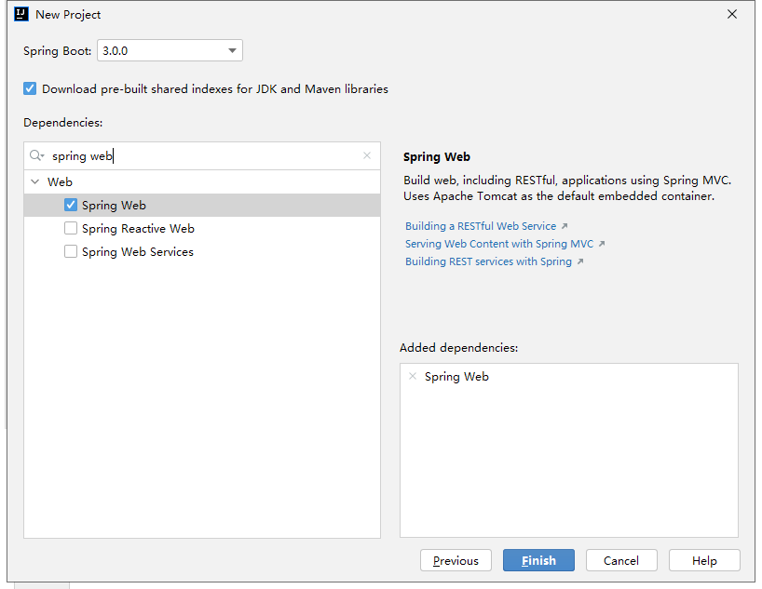

### Step 1.2 Download Project Setup from Spring Initializr

* Make sure you include Spring Web library

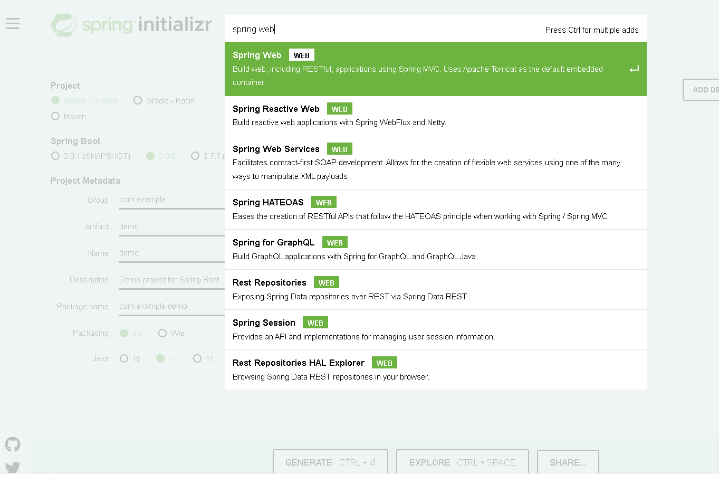

## Step 2. Create your first API

### 2.1 Locate your Project

Once you setup your project successfully, you can find XXXApplication.java in your folder. This is the runnable program in your project. Make sure your new folders and files has hierarchy lower than main program.

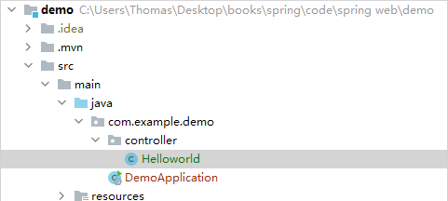

### 2.2 Create controller

🡪 Type this code

@RestController  
@RequestMapping(**"/test"**)  
**public class** Helloworld {  
 @GetMapping(**"/helloworld"**)  
 **public** String helloworld(){  
 **return "Hello World!!!"**;  
 }  
}

## Step 3. Test your outcome

Simply open your browser and type: <http://localhost:8080/test/helloworld>. It will show you pure text result

